IMAGE FUSION USING CT AND MRI IMAGES

**DR.T.Jackulin**

Associate Professor

Department of Computer Science And Engineering

Panimalar Engineering College

**Mahima T.P ,Sowmiya K ,Thokala Veshitha**

Department of Computer Science And Engineering

Panimalar Engineering College

[mahiprem2000@gmail.com](mailto:mahiprem2000@gmail.com) [sowmiyaksjdms@gmail.com](mailto:sowmiyaksjdms@gmail.com) [veshitha18072001@gmail.com](mailto:veshitha18072001@gmail.com)

**ABSTRACT**

**Fusing different medical images will increase the accuracy in diagnosis of disease and describe the complicated relationship between them for medical research. The existing methods are time consuming and also requires more number of samples to train the models. In this model, we will retrieve the complicated information from different medical images like Magnetic Resonance Imaging (MRI) and Computed Tomography (CT) by fusing them through multi-stage fusion networks. In the proposed model, we will use Dual Tree Complex Wavelet Transform (DTCWT) to extract the complicated and correlated information from each images and segmentation is done on fused image to get the segmented image. In the proposed method, the fusion of multi model medical images can be done by Dual Tree Complex Wavelet Transform, where the source medical image is converted to grayscale and decomposed, then the wavelet coefficients are extracted using DTCWT. After that, the approximation of wavelets are done to obtain the fused coefficients. Finally Inverse Dual Tree Complex Wavelet Transform is applied to obtain the final fused image. Additionally segmentation is performed to obtain the segmented image for the purpose of getting enhanced visual representation. In the proposed method, the improved quality of final fused image can be obtained.**

**Keywords:Medical image fusion DTCWT ,PCA , VGG19**

**I.INTRODUCTION**

X-ray, Positron Emission Tomography (PET), Single Photon Emission Computed Tomography (SPECT), Magnetic Resonance Imaging (MRI), and Computed Tomography (CT) medical images, will not provide as much as detailed information for medical based research and diagnosis. They are required to provide a lot of elaborated clinical data. In order to extract all the complicated information from a single we are fusing the medical images of single or different systems. The medical image fusion is defined as the process of merging different kinds of medical images or of similar types into a single image that provides more accurate information for diagnosis that will be helpful for better and accurate treatment. The doctors will able to extract the detailed and complicated data from the fused images of the medical images which are not visible in individual images.

**II.LITERATURE SURVEY:**

# In 2016, Padmavathi K, Maya V KarKi, Mahima Bhat, Medical image fusion of different modalities using dual tree complex wavelet transform with PCA, in this paper different characteristics of low and high frequency sub bands are taken into account and fusion rules are applied. DTCWT is applied to extract salient information from each modality. Fusion rule is applied with PCA features. Improvement in visual quality can be seen in the proposed method.[2]

# In 2013, Rajiv Singh, Ashish Khare, Multimodal medical image fusion using Daubechies complex wavelet transform, Shift sensitivity and lack of phase information in real valued wavelet transforms motivated to use DCxWT for multimodal medical image fusion. It was experimentally found that shift invariance and phase information properties improve the performance of image fusion in complex wavelet domain. Therefore, DCxWT is used for fusion of multimodal medical images.[3]

In 2013, Negar Chabi, Mehran Yazdi, Mohammad Entezarmahdi, An efficient image fusion method based on dual tree complex wavelet transform,  Approximate shift-invariance property and availability of phase information in DTCWT are useful in the fusion process. The approximate shift-invariance property of DTCWT is important in robust sub-band fusion and also makes it to avoid loss of important image content at multiple levels. On the other hand, the availability of phase information in complex coefficients of DTCWT is useful in encoding more coherent structures of the fused images.[4]

In 2014, Himanshi, Vikrant Bhaterja Abhinav Krishn, and Akanksha Sahu, An improved Medical Image Fusion Approach Using PCA and Complex Wavelets, Unlike real valued discrete wavelet transforms, DTCWT provides shift invariance and improved directionality along with preservation of spectral content. The decomposed images are then processed using PCA a based fusion rule to improve upon the resolution and reduce the redundancy. Simulation results demonstrate an improvement in visual quality of the fused image supported by higher values of fusion metrics. [6]

In 2005,  P.R.Hill, D.R.Bull & C.N Canagarajah, Image fusion using a new framework for complex wavelet transform ,This paper therefore introduces an alternative structure to the DT-CWT that is more flexible in its potential choice of filters and can be implemented by the combination of four normally structured wavelet transforms. The use of these more common wavelet transforms enables this method to make use of existing optimised wavelet decomposition and recomposition methods, code and filter choice.[10]

In 2004, S.Kor,U.S.Tiwary, feature level fusion of multimodal medical images in lifting wavelet transform domain, The feature fused is edge and boundary information of input images that is extracted using wavelet transform modulus maxima criterion. The image fusion performance is evaluated by standard deviation, entropy, cross entropy and gradient parameters. Experimental results show that the proposed method gives better results for image fusion as image contrast, average information content and detail information of fused image are increased.[13]

**III.EXISTING SYSTEM**

Discrete wavelet transform can make different input frequency signals maintaining stable output and has good positioning in the time domain and frequency domain, which helps to preserve the specific information of the image. The discrete wavelet transform overcomes the limitations of the principle component analysis and has a good visual and quantitative fusion effect. The source image is preprocessed and enhanced, and the intensity component is extracted from the CT image using the HIS transform, which preserves more anatomical information and reduces color distortion. The DWT transform is performed on the intensity components of MRI and CT to obtain high- and low-frequency subbands. The high- and low-frequency subbands are, respectively, fused by different fusion rules, and the inverse DWT transform is performed to obtain the fused image.

The absolute high-value method is used to fuse the decomposed high-frequency coefficients, the weighted average method is used to fuse the low-frequency coefficients, the predator-optimizer is used to estimate and optimize the weights, and finally, the inverse transform is used to obtain the fused images. The concept of fusion is done by applying two fusion rules. Low and high frequency coefficients have different meaning so different rules were applied to fuse them.First set of rules are, the larger wavelet coefficients mean salient features of images like corners and edges, selecting larger wavelet coefficient is the most common way to fuse details, because higher values mean stronger edges and are preferred as important part of information content. Low values of wavelet coefficients depict approximation of source images thus averaging is used to obtain information about both source images. After the approximation of the extracted wavelet coefficients, the inverse Discrete Wavelet Transform is applied to obtain the fused image.

The CT image of a patient brain diseased by Sarcoma is shown in figure 3.2 and the MRI image of the same patient is shown in figure 3.3. These two multimodal images were fused by applying Discrete Wavelet Transform algorithm.After the extraction of the wavelet coefficients and further fusion rule is applied to fuse the coefficients.

Fig 1: Source CT image of a patient diseased by Sarcoma

Fig 2:Source MRI image of a patient diseased by Sarcoma

After fusing the extracted wavelet coefficients using the derived fusion rules, the Inverse Discrete Wavelet Transform is applied to obtain the final fused image. The final fused image is shown in figure 3.4. The problems related with DWT are, it does not provide sufficient directional information and results in an image with shift variance and additive noise. It also does not preserves time and frequency information and hence it is not as efficient to represent the enhanced visual representation of the fused image.

Fig3: DWT fused image

**IV.PROPOSED SYSTEM**

The medical image fusion is defined as the process of merging different kinds of medical images or of similar types into a single image that provides more accurate information for diagnosis that will be helpful for better and accurate treatment. The doctors will able to extract the detailed and complicated data from the fused images of the medical images which are not visible in individual images.

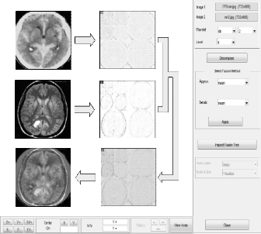Medical image fusion tools are used in the medical department like oncology and cancer research therapy. A perfect image fusion process should get the complementary information of the source images in final fused image while neglecting the unwanted and unexpected features. Image fusion can be done at three levels, they are pixel level, characteristics level and decision level. Pixel level fusion is designed to merge multiple source images into a final combined image, which will give more information for machine and human perception as compared to any of the source image. Next is the characteristics level image fusion is also referred as middle level image fusion. This process can represent and analyze the multi-sensor data for realizing classification. This technique plays a vital role in theoretical and analytical tool for image and signal processing. The final level of image fusion is decision level, this is the process of combining information at a higher level and also merge the results from various algorithm to get a final fused decision. Here the input images are processed individually for information extraction.

MRI, also known as Magnetic Resonance Imaging, provides information on the soft tissue structure of the brain without functional information. The density of protons in the nervous system, fat, soft tissue, and articular cartilage lesions is large, so the image is particularly clear and does not produce artifacts. It has a high spatial resolution and no radiation damage to the human body, and the advantage of rich information makes it an important position in clinical diagnosis. The density of protons in the bone is very low, so the bone image of MRI is not clear. The CT image is called Computed Tomography imaging. The high-density absorption rate of bone tissue relative to soft tissue makes the bone tissue of the CT image particularly clear. CT images show less cartilage information, which represents anatomical information. The proposed framework realizes Dual Tree Complex Wavelet Transform is implemented in the image fusion. The dual tree complex wavelet transform will be the solution for the shortcomings of Discrete Wavelet Transform (DWT). The DTCWT will provide better directionality and the shift variance which is easy to process the edges and contours of the source image.

Fig 4:Fusing CT and MRI images using Python wavelet tool

**DUAL TREE COMPLEX WAVELET TRANSFORM**

Dual Tree Complex Wavelets could provide approximate shift invariance and good directionality, but perfect reconstruction and achieving good frequency characteristics was impossible using a single tree. However, approximate shift invariance could be obtained by doubling sampling rate at each level of tree. For this, samples must be spaced evenly. This could be acquired by eliminating downsampling of 2 after level 1 filters, H0a and H1a. The real and imaginary parts of complex coefficients are shown. Another way to achieve this goal is to use two parallel fully decimated trees, a and b. To get uniform intervals between samples of two trees below level 1, filters of one tree should have a half sample different delay from other tree. To reach linear phase, this necessitates odd-length of filters in one tree and even-length filters in other tree. Greater symmetry exists between trees if even and odd filers are used in levels of tree, alternatey. To invert the transform, PR filters are applied in usual way to invert each tree separately and finally the two results are averaged.This process does not seem to yield a complex transform at all. The transform becomes complex if the outputs of two trees are defined as real and imaginary parts of complex wavelet. For filters of linear phase PR biorthogonal sets, even length filters have odd symmetry around their midpoints; meanwhile odd-length filters possess even symmetry.

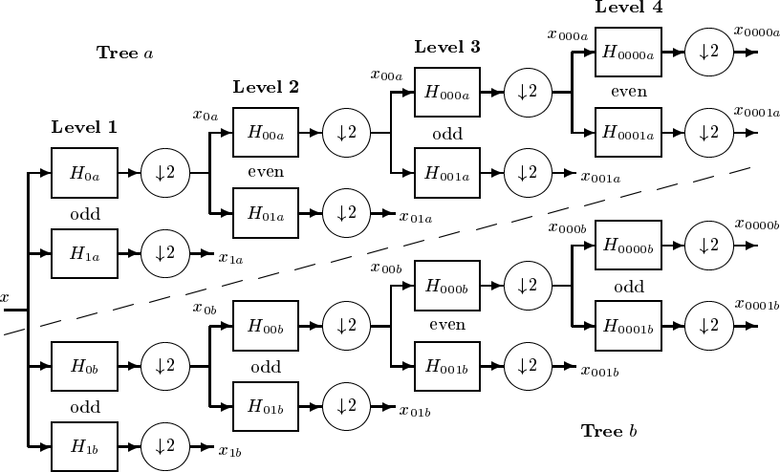

**Fig 5:** Dual tree of real filters for DTCWT

The impulse response of these filters look like the real and imaginary parts of complex wavelets. Extension to 2-D is achieved by separable filtering along columns and them rows. But, if column and row filters reject negative frequencies, only the first quadrant of 2-D signal spectrum is preserved.Two adjacent quadrants of the spectrum should represent a real 2-D signal, so filtering is performed with complex conjugates of the row filters, too. This gives 4:1 redundancy in the transformed 2-D signal.A normal 2-D DWT yields three bandpass sub images at each level, horizontal details of image, vertical details and diagonal details.2-D DTCWT presents three sub images at each spectral quadrants 1 and 2, giving six bandpass sub images of complex coefficients at each level, oriented at angles of ±15, ±45, ±75.

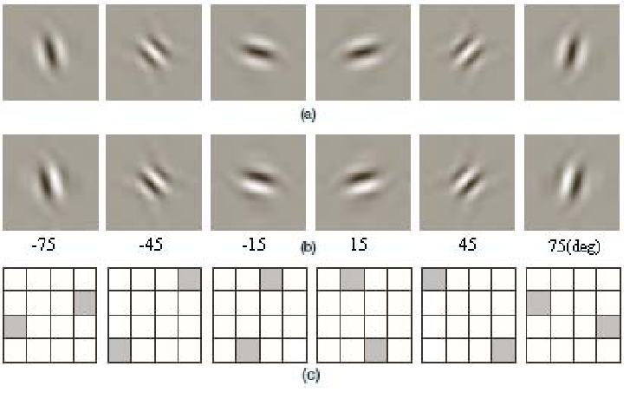

Fig 6: Typical wavelets associated with 2-D DTCWT for 6 subbands.

**PRINCIPAL COMPONENT ANALYSIS**

Principal component analysis (PCA) is a technique to bring out strong patterns in a dataset by supressing variations. It is used to clean data sets to make it easy to explore and analyse. The algorithm of Principal Component Analysis is based on a few mathematical ideas namely: Variance and Convariance and eigen vector and eigen values.We will explain the two topics in simple terms in the steps below so that you can follow along and learn enough to implement your own Principal Component Analysis code in any language.

**VGG-19**

After the feature fusion , the image is passed to VGG-19 and the following procedure is implemented:A fixed size of (224 * 224) RGB image was given as input to this network which means that the matrix was of shape (224,224,3).The only preprocessing that was done is that they subtracted the mean RGB value from each pixel, computed over the whole training set.Used kernels of (3 * 3) size with a stride size of 1 pixel, this enabled them to cover the whole notion of the image.

Spatial padding was used to preserve the spatial resolution of the image.Max pooling was performed over a 2 * 2 pixel windows with sride 2.This was followed by Rectified linear unit(ReLu) to introduce non-linearity to make the model classify better and to improve computational time as the previous models used tanh or sigmoid functions this proved much better than those.Three fully connected layers are implemented from which first two were of size 4096 and after that a layer with 1000 channels and the final layer is a softmax function.

**V.SYSTEM ARCHITECTURE**

The source images considered are the combination of MRI and CT images. The first step of the proposed scheme is to convert the RGB images into gray scale images. Then the gray scale images are decomposed by applying the dual tree complex wavelet transform (DTCWT). The wavelet coefficients and approximation are extracted from the decomposed images. The DTCWT will produce various levels of decomposed images. At each level the images are segmented into sub-bands at six directions like - 15o, -45o, -75o, 15o, 45o, 75o to extract the details from the image. On each sub-bands principal component analysis (PCA) is applied to extract the silent features.

Fuse the extracted coefficients and its approximation by applying the fusion rule and to restore the fused image apply the inverse dual tree complex wavelet transform (IDTCWT). Finally segmentation is performed on the fused image to locate the objects and boundaries like lines and curves. It is the process of allocating artifact to each and every pixel in fused image, such that pixel having the same artifact show certain characteristics. Hence the colored image is obtained.

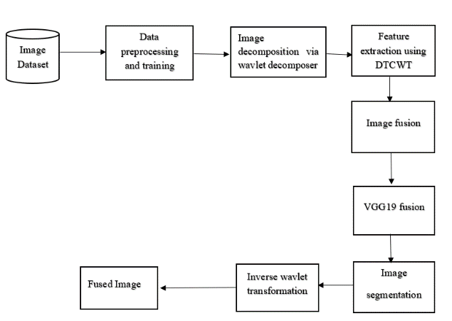

Fig 7:System architecture diagram

**VI.RESULTS AND DISCUSSION**

Medical images are used for diagnosis the disease and helpful for treatment. The fused medical image will be used for more accurate diagnosis and gather the elaborated information for better treatment. But in the fused, we are not achieving more accurate images. In order to achieve visually intensified fused image. In this project, we presented medical fusion based on dual tree complex wavelet transform. The dual tree complex wavelet transform based fusion will compute the fused multi model image which

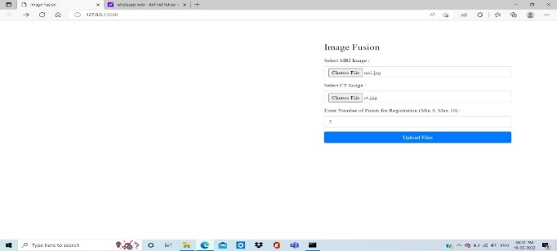 shows good selectivity of directionality and better shift variance. In this project, our proposed method accepts source images as computed tomography (CT), magnetic resonance imaging (MRI) and decompose them with DTCWT. Further, extraction of coefficients and approximation of extracted coefficients are performed. Then the inverse dual tree complex wavelet transform is applied to get the fused image, finally segmentation is performed to obtain the segmented fused image. Hence, the fused image of our proposed scheme, exhibits more refined edges, tissues, spectral, contour and spatial details of the tumor.

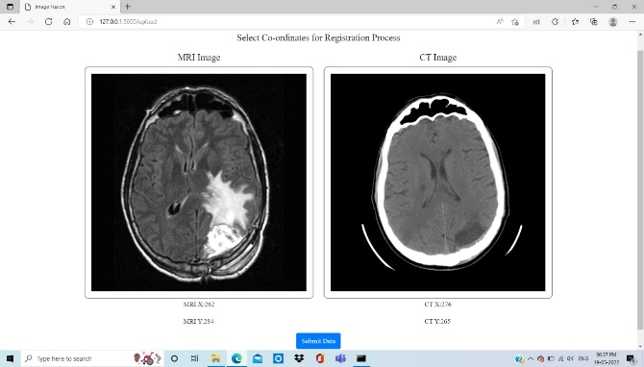Fig 8:upload page in image fusion

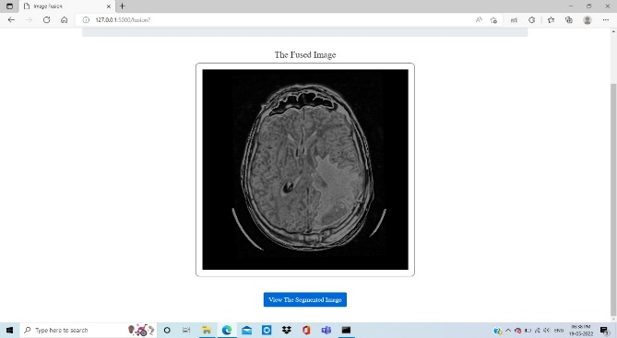 Fig 9:co-ordinates selection page in image fusion

Fig 10:fused image display page in image fusion

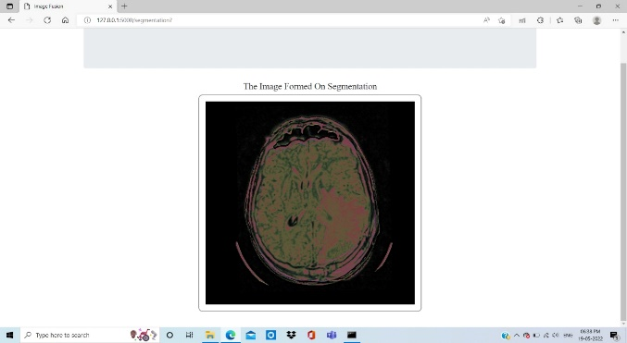 Fig11:image segmentation display page in image fusion

**VII.PERFORMANCE ANALYSIS**

Precision is the ratio between the True Positives and all the Positives. Our Project precision value is around 0.872 which would be 87 %.The recall is the measure of our model correctly identifying True Positives. Recall also gives a measure of how accurately our model is able to identify the relevant data. Our Project Recall value is around 0.865 which would be 86 %.O (1) is the time complexity which means that whatever is the size of the input, the time taken by the program to run is constant. That is the reason O (1) time complexity is called constant time complexity.Accuracy is 95% where as accuracy of existing systems is only 92%.

**VIII.CONCLUSION:**

Our proposed method of medical image fusion is based on Dual Tree Complex Wavelet Transform (DTCWT), since it has proved that it provides the fused image with more refined in representing spectral, spatial, and soft tissue details of the tumor. With concern about the performance level, our proposed method has high values of entropy, fusion factor and peak signal to noise ratio. Hence our proposed algorithm performs well compared to other fusion methods. As a future work, block level fusion can be applied and the results like performance evaluation, and the final fused image regarding enhanced visual representation can be further improved.

**REFERENCE:**

1. Tannaz akbarpour, Mousa shamsi, Sabalan Daneshvar, “Structural medical image fusion by means of dual tree complex wavelet”, The 22nd Iranian Conference on Electrical engineering (ICEE 2014), pp.1970- 1975, May 20-22, 2014.
2. Padmavathi K, Maya V KarKi, Mahima Bhat, “Medical Image Fusion of Different Modalities Using Dual Tree Complex Wavelet Transform With PCA”, 2016 International Conference on Circuit, Communication and Computry (I4C), October 2016.
3. Rajiv Singh, Richa Srivastava, Om Prakash and Ashish Khare, “Mixed scheme based multimodal medical image fusion using Daubechies Complex Wavelet Transform”, IEEE/OSA/IAPR International Conference on Informatics, Electronics & Vision, (ICIEV), pp. 304-309, 2012.
4. Negar Chabi, Mehran Yazdi, Mohammad Entezarmahdi, “An efficient image fusion method based on dual tree complex wavelet transform”, 8th IEEE Iranian Conference on Machine Vision and Image Processing (MVIP), pp. 403-407, 2013.
5. Ivan W. Selesnick, Richard G. Baraniuk, Nick G. Kingsbury, “The Dual-Tree Complex Wavelet Transform, A coherent framework for multiscale signal and image processing”, IEEE, signal processing Magazine, pp.123-151 Nov-2005.
6. Himanshi, Vikrant Bhaterja Abhinav Krishn, and Akanksha Sahu, “An improved Medical Image Fusion Approach Using PCA and Complex Wavelets”, IEEE International conference on Medical Imaging, m- Health and Emerging Communication systems (MedCom) , pp. 442-447, 2014.
7. Sruthy S, Dr. Latha Parameswaran , Ajeesh P Sasi, “Image Fusion Technique using DT-CWT”, IEEE, pp. 160-164,2013
8. Sonali Mane, S.D. Sawant, “Image Fusion of CT/MRI using DWT, PCA Methods and Analog DSP Processor”, International Journal of Engineering Research and Applications ISSN:2248-9622, Vol. 4, Issue 2(Version 1), pp.557-563, February 2014.
9. Rajiv Singh, Ashish Khare, “Multimodal medical image fusion using Daubechies complex wavelet transform”, Proceedings of IEEE Conference on information and communication technologies (ICT) ,pp. 869-873, 2013.
10. P.R.Hill, D.R.Bull & C.N Canagarajah, “Image fusion using a new framework for complex wavelet transform”, IEEE, September, 2005.
11. J. Ruf, E. Lopez Hänninen, M. Böhmig, I. Koch, T. Denecke, M. Plotkin, et al. “Impact of FDG-PET/MRI Image fusion on the Detection of Pancreatic Cancer” . *pancheratology* , vol.6, pp.512-519, 2006.
12. I. Jambor, R. Borra, J.Kemppainen, V.Lepomäki, R.Parkkola, K. Dean, et al.” Improved detection of localized prostate cancer using co-registered MRI and 11C-acetate PET/CT” , *Europian Journal of Radiology,* vol.81 , pp. 2966-2972, 2012.
13. S.Kor,U.S.Tiwary,”feature level fusion of multimodal medical images in lifting wavelet transform domain*”, Engineering in Medicine and biology Society,2004.IEEE-EMBs. 26th Annual Conference of the*,On page(s) 1479-1482.
14. I.W.Selesnick, R.G.Baraniuk, N.C.Kingsbury. “ The dual tree complex wavelet transform “ . *Signal processing magazine*,vol.22,pp. 123-151,2005.
15. J.Magarey, N.C.Kingsbury. “ Motion estimation using a complex- valued wavelet transform”. *Signal Processing , IEEE transactions on,* vol.46,pp.1069-1084,1998.
16. W.Wang,P.Shui, G.Song. “Multifocus image fusion in wavelet domain”. *Machine Learning and Cybernetics, 2003 International Conference on,*2003,pp.2887-2890.
17. B.Yang,S.Li. “ Pixel level image fusion with simultaneous orthogonal matching pursuit”. *Information fusion,* vol.13, pp 10-19,2012..
18. S.Li,J.T.Kwok, Y.Wang. “ Multifocus image fusion using artifical neural networks” . Patteren recognition letters, vol.23, pp.985- 997,2002.
19. S.Daneshvar, H.Ghasemian.”MRI and PET image fusion by combining IHS and retina-inspired models”. *Information fusion*,vol.12 ,pp.114-123, 2010.
20. A.Toet, J.J.Van Ruyven, J.M,Valeton. “ Merging thermal and visula images by a contarst pyramid” . *Optical engineering* ,vol.28,pp.789- 792,1989